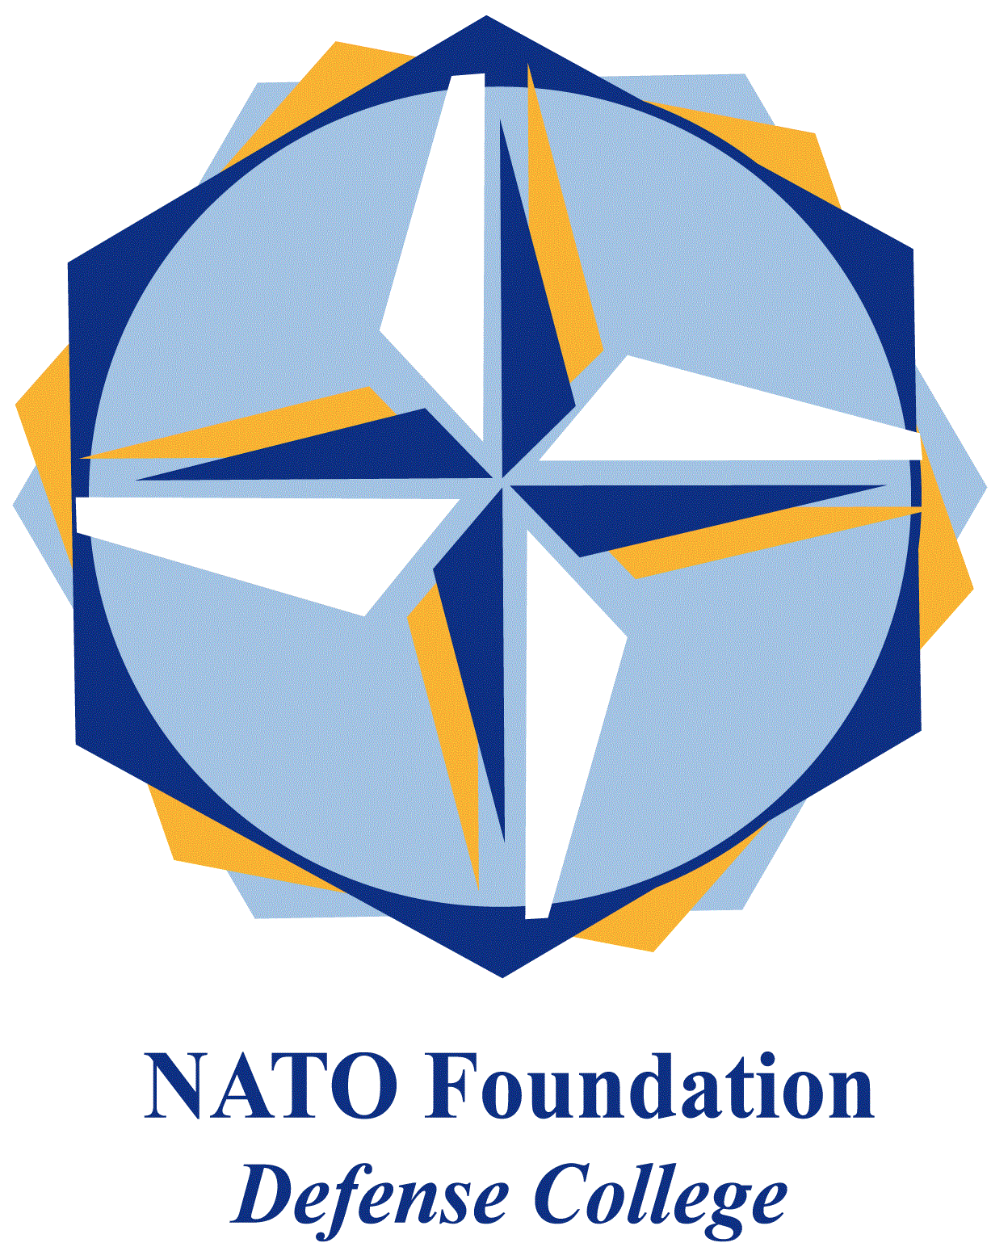
NATO DEFENSE COLLEGE FOUNDATION
STRATEGIC TRENDS
November 2015
MAGHREB
The overhaul of the security services and the power struggle in Algeria
On November 12 a court in Milan ordered the requisition of properties in Sonatrach corruption case. The preventive measure established by the court was directed against Pietro Varone (Saipem’s former director) and two Algerian businessmen, Farid Bedjaoui and Samir Ouraied. According to the accusations, Sonatrach allegedly received €198 millions in bribes in order to grant a €8 billion contract to the Italian company.
The affaire could be interpreted as a new corruption case with limited consequences on the Algerian business climate. However, an in-depth look at the main actors involved reveals important political ramification. Bedjaoui in particular is considered a strict associate of the powerful Chakib Khalil, former Energy Minister. Hit by an international arrest warrant during the inquiry, Khalil exiled himself in the United States.
The involvement of Khalil in the Sonatrach – Saipem affaire has been a serious blow for the Algerian President Abdelaziz Bouteflika. Many analysts believe that it was at this time that the relationship between the President and the intelligence sharply deteriorated. Among the numerous tasks of the mighty Département du reinsegnement et de la sécurité (DRS), corruption investigation has always been a sensitive issue.
After his re-election in 2014, Bouteflika thus implemented an overhaul of the intelligence and the security services. The reform was intended to produce a more efficient intelligence apparatus, with an exclusive focus on its core business. Nevertheless critics argue that the real scope of this operation (known in the Algerian press as ‘effreuillage’) was to curb the powers of DRS, removing the last generation of ‘janvieristes’ responsible of the halt of the electoral process in 1992. Started in 2013, the purge continued this year when Bouteflika sacked several figures, including the head of the DRS Mohamed Mediène, also known by the nickname of Toufik.
After 25 years in charge of the intelligence affairs, last September Mediène was replaced by General Athmane Tartag. The fall of Mediène represents the ultimate effect of the chain of reaction originated by the Sonatrach – Saipem corruption scandal. It could be also ascribed to the current succession race to the ailing President: in the removal of Toufik many see the hidden hand of its brother Said Bouteflika. In a political perspective, it is likely that the overhaul of the Algerian security services will strengthen the civilian control over the military in the long term. Some doubts emerge however over the possible effects of this reform on the security sector, in a country where the military and police forces have been able to defuse the terrorist threat so far.

